Ex. No. 6 | Persistence Storage with SQLite Database
Date of Exercise | 03-10-2025

Github Code Link

Video Link

Aim:
To design and implement a mobile application that demonstrates persistent data storage using the SQLite database, enabling users to store and retrieve data thereby ensuring data remains available even after the application is closed or restarted.
Description:
- Flutter apps are mobile-first.
- SQLite is a lightweight relational database that works offline.
- With Flutter, you typically use the sqflite plugin to interact with SQLite.
Persistence Storage
- Persistence Storage means storing data permanently on a mobile device, so that the data is not lost when the app is closed or the phone is restarted.
- SQLite is a lightweight, self-contained, serverless, zero-configuration SQL database engine.
- The entire database is stored in a single file on the device (e.g.,students.db).
- Relational Database – Uses SQL (Structured Query Language) for queries.
Integrate SQLite Database in Flutter Project
- Add dependencies in pubspec.yaml:
  - sqflite: ^2.3.0
  - path_provider: ^2.1.2
- Install Android Studio
  - Create Android Virtual Device(AVD)
  - Start the AVD or connect Real Android Device
- Create a data model class
- Create a DatabaseHelper class for SQLite operations.
  - Create database
  - Create Table
  - Insert, Read, Update and Delete
- Create Flutter UI Design and call SQLite operations via DatabaseHelper functions.
Question:
Product Inventory Tracker
Scenario:
A small shop wants to keep track of the products in its inventory.
Requirements:
- Create a table: products (id, name, quantity, price).
- On a single screen, allow the user to:
  - Enter a product’s name, quantity, and price.
  - Save the product into SQLite.
  - Display all products in a ListView below the form.
- Display total stock value = Σ(quantity × price) at the bottom.
- Highlight products where quantity &lt; 5 with a red warning: “Low Stock!”.

Program:
Main.dart
import 'package:flutter/material.dart';
import 'package:persistent_storage/databasehelper.dart';
import 'package:sqflite/sqflite.dart';
import 'product.dart';
void main() {
WidgetsFlutterBinding.ensureInitialized();
runApp(const MyApp());}
class MyApp extends StatefulWidget {
const MyApp({super.key});
@override
State<MyApp> createState() => _MyAppState();}
class _MyAppState extends State<MyApp> {
final _formKey = GlobalKey<FormState>();
final _nameController = TextEditingController();
final _quantityController = TextEditingController();
final _priceController = TextEditingController();
List<Product> _products = [];
@override
void initState() {
super.initState();
_showAllProducts(); }
Future<void> _showAllProducts() async {
final products = await DatabaseHelper.instance.readAllProducts();
setState(() {
_products = products;
});}
double getTotalStockValue() {
return _products.fold(
0,
(sum, product) => sum + (product.quantity * product.price),
);}
@override
Widget build(BuildContext context) {
return MaterialApp(
title: "Product Inventory Tracker",
home: Scaffold(
backgroundColor: const Color.fromARGB(255, 243, 242, 225),
appBar: AppBar(
title: const Text("Product Inventory Tracker"),
backgroundColor: const Color.fromARGB(255, 255, 175, 2), ),
body: Container(
padding: const EdgeInsets.all(20),
child: Form(
key: _formKey,
child: Column(
children: [
TextFormField(
controller: _nameController,
keyboardType: TextInputType.text,
decoration: const InputDecoration(
labelText: "Enter product name", border: OutlineInputBorder()),
validator: (value) {
if (value == null || value.isEmpty) {
return "Please enter the product name";}
return null;
},),
const SizedBox(height: 10),
TextFormField(
controller: _quantityController,
keyboardType: TextInputType.number,
decoration: const InputDecoration(
labelText: "Enter product quantity", border: OutlineInputBorder()),
validator: (value) {
if (value == null || value.isEmpty) {
return "Please enter the product quantity";
}return null;
},),
const SizedBox(height: 10),
TextFormField(
controller: _priceController,
keyboardType: TextInputType.number,
decoration: const InputDecoration(
labelText: "Enter product price", border: OutlineInputBorder()),
validator: (value) {
if (value == null || value.isEmpty) {
return "Please enter the product price";}
return null;},),
const SizedBox(height: 10),
Builder(
builder: (context) {
return ElevatedButton(
style: ElevatedButton.styleFrom(
backgroundColor: const Color.fromARGB(255, 255, 132, 31),
foregroundColor: Colors.black, ),
onPressed: () async {
if (_formKey.currentState!.validate()) {
String name = _nameController.text;
int quanity = int.parse(_quantityController.text);
double price = double.parse(_priceController.text);
Product product = Product(name: name, quantity: quanity, price: price);
await DatabaseHelper.instance.insertProduct(product);
await _showAllProducts();
ScaffoldMessenger.of(context).showSnackBar(
const SnackBar(
content: Text("Product Details Saved")),
);
_nameController.clear();
_quantityController.clear();
_priceController.clear();
}},
child: const Text("Add Product"),
);},),
const SizedBox(height: 10),
Expanded(
child: _products.isEmpty
? const Center(child: Text("No products found"))
: ListView.builder(
itemCount: _products.length,
itemBuilder: (context, index) {
final product = _products[index];
return ListTile(
leading: CircleAvatar(
child: Text(product.name[0]),
backgroundColor: product.quantity<5?Colors.red:Colors.blue, ),
title: Text(product.name),
subtitle: Column(
crossAxisAlignment: CrossAxisAlignment.start,
children: [
Text("Quantity: ${product.quantity}, Price: ${product.price}"),
if (product.quantity<5)
const Text("Low Stock!", style: TextStyle(color:Colors.red)),
], ), );},),
),
Padding(
padding: const EdgeInsets.all(8.0),
child:Text(
"Total Stock Value: ${getTotalStockValue()}",
style:const TextStyle(fontWeight:FontWeight.bold,fontSize:16),
), ),
],),),),), );}}
product.dart
class Product{
int? id;
String name;
int quantity;
double price;
Product({
this.id,
required this.name,
required this.quantity,
required this.price });
factory Product.fromRow(Map<String,dynamic> row){
return Product(
id:row['id'],
name:row['name'],
quantity:row['quantity'],
price:row['price']
);}}
databasehelper.dart
import 'package:sqflite/sqflite.dart';
import 'package:path/path.dart';
import 'package:path_provider/path_provider.dart';
import 'dart:io';
import 'product.dart';

class DatabaseHelper {
static Database? _database;
static DatabaseHelper instance = DatabaseHelper._privateConstructor();
DatabaseHelper._privateConstructor();
Future<Database> get database async{
if(_database!=null) return _database!;
Directory dir= await getApplicationDocumentsDirectory();
String path=join(dir.path,"products.db");
_database=await openDatabase(
path,
version: 1,
onCreate: (db,version) async{
String sql="CREATE TABLE products(id INTEGER PRIMARY KEY AUTOINCREMENT,name TEXT,quantity INTEGER,price REAL)";
await db.execute(sql);
}, );
return _database!; }
Future<int> insertProduct(Product product) async{ Database db=await instance.database; return await db.insert('products',{'name':product.name,'quantity':product.quantity,'price':product.price});
}
Future<List<Product>> readAllProducts() async{
Database db=await instance.database;
final records=await db.query("products");
return records.map((record)=>Product.fromRow(record)).toList();
}
Future<int> resetProducts() async {
final db = await instance.database;
return await db.delete("products");
}}
Output Screenshot:
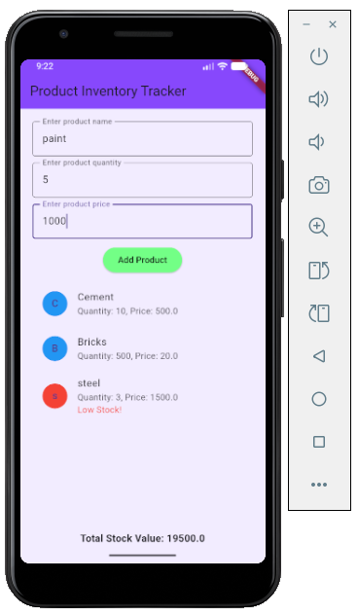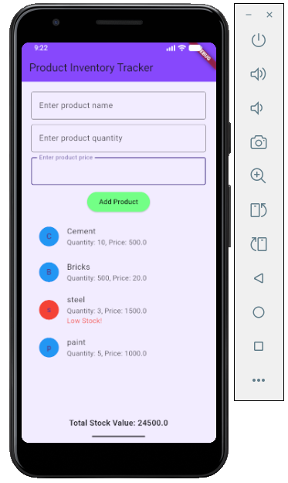
Result:
Thus successfully designed and implemented a mobile application that demonstrates persistent data storage using the SQLite database, enabling users to store and retrieve data thereby ensuring data remains available even after the application is closed or restarted.

